**PRACTICAL 1:**

**AIM:** To Perform Amplitude Shift Keying.

**Software used:** Multisim.

**Theory:**

Amplitude Shift Keying (ASK) is a modulation technique used in digital communication systems to encode digital data onto an analog carrier wave. In ASK, the amplitude of the carrier signal is varied in accordance with the digital information being transmitted. This modulation allows for the transmission of digital data over analog channels.

In ASK, the digital signal to be transmitted is represented by different amplitude levels of the carrier signal. Typically, one amplitude level represents a binary '1', while another represents a binary '0'. The carrier signal is then modulated to switch between these amplitude levels to convey the digital information.

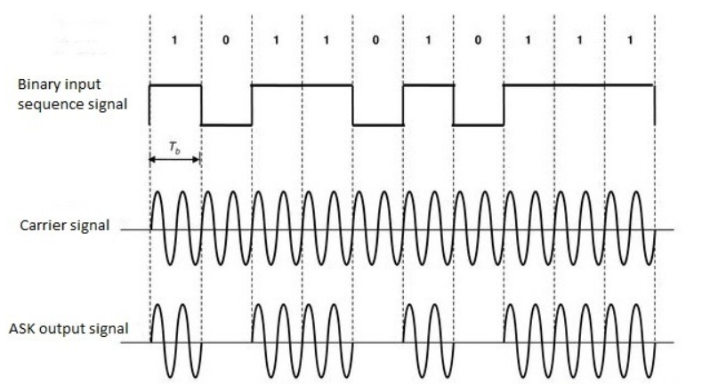

When the switch is closed – for all the logic HIGH time intervals i.e. when the input signal having logic 1 during those intervals the switch is closed and it is multiplied with the carrier signal which is generating from the function generator for the same duration.

When the switch is opened – when the input signal having logic 0, the switch is opened and there is no output signal will be generated. Because the input binary signal logic 0 having no voltage, so during these intervals when the carrier signal multiples with it, zero output will come. The output is zero for all logic 0 intervals of the input binary signal. Mixer circuit having the pulse shaping filters and band-limited filters for shaping the ASK output signal.

**Circuit:**

**Output:**

**PRACTICAL 2:**

**AIM:** To Perform Frequency Shift Keying.

**Software used:** Multisim.

**Theory:**

frequency Shift Keying (FSK) is a digital modulation technique used in telecommunications to encode digital data onto an analog carrier wave by varying the frequency of the carrier signal. In FSK, different frequencies represent different symbols or bits of digital information.

There are typically two variants of FSK:

**Binary Frequency Shift Keying (BFSK):** In BFSK, there are two distinct frequencies, often referred to as the "mark" and "space" frequencies. Each frequency corresponds to a binary symbol, with one frequency representing a binary '1' and the other representing a binary '0'. The transmitter switches between these two frequencies to encode the digital data.

**Multiple Frequency Shift Keying (MFSK):** MFSK extends BFSK by using more than two frequencies to represent multiple symbols or bits per symbol. Each frequency corresponds to a unique combination of binary symbols, allowing for higher data rates compared to BFSK. Common variants of MFSK include 4FSK, 8FSK, and 16FSK, which use 4, 8, and 16 distinct frequencies, respectively.

FSK modulation techniques are commonly used in various communication systems, including radio communication, digital broadcasting, and data modems. They offer advantages such as simplicity of implementation, robustness to noise, and compatibility with frequency division multiplexing (FDM) techniques. However, FSK modulation is limited by its bandwidth efficiency compared to other modulation techniques like phase shift keying (PSK) and quadrature amplitude modulation (QAM).

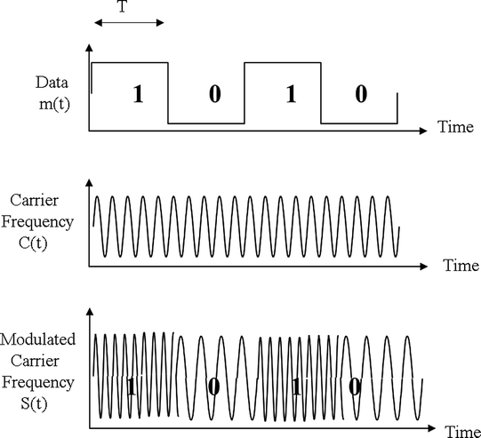

**Circuit:**

**Output:**

**PRACTICAL 3:**

**AIM:** To Perform Phase Shift Keying.

**Software used:** Multisim.

**Theory:**

Phase Shift Keying (PSK) is a modulation technique used in digital communication systems to encode digital data onto an analog carrier wave by varying the phase of the carrier signal. In PSK, the phase of the carrier wave is adjusted to represent different symbols or bits of digital information.

There are two variants of PSK, including Binary Phase Shift Keying (BPSK), Quadrature Phase Shift Keying (QPSK):

**Binary Phase Shift Keying (BPSK):** In BPSK, the carrier wave is shifted between two phase states, typically 0 degrees and 180 degrees. Each phase state represents a binary symbol, with one phase state corresponding to a binary '1' and the other to a binary '0'. BPSK is relatively simple but is susceptible to phase ambiguity, where the receiver may incorrectly interpret the phase due to phase wrapping or phase drift.

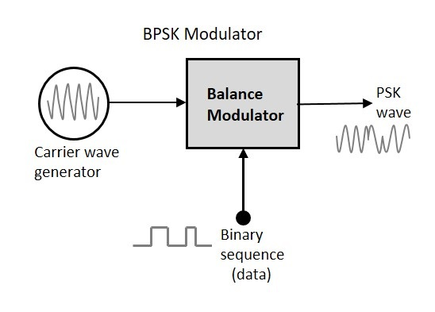

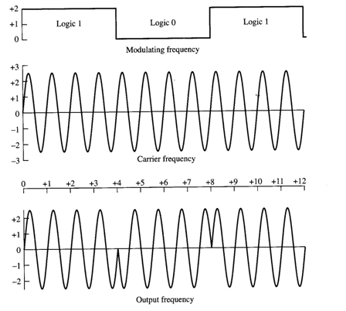

**Quadrature Phase Shift Keying (QPSK):** QPSK extends BPSK by encoding two bits per symbol. It achieves this by using four phase states, typically 0, 90, 180, and 270 degrees. Each combination of phase states represents a unique pair of binary symbols. QPSK offers higher data rates compared to BPSK but is more susceptible to phase noise.

**Circuit:**

**Output:**

